Software Requirement Specifications
<AI-Integrated Web-Based Chemical Lab Inventory Management System>


Submitted by:
Khazima Amin (1202)

Submitted to:
Mr. Faisal Shahzad

Department of Information Technology
Faculty of Computing
The Islamia University of Bahawalpur

Meeting Details
Sr No | Details | Date | Supervisor Signature

Summary

The AI-Integrated Web-Based Chemical Lab Inventory Management System is developed to address the growing need for digital transformation in educational laboratories. Currently, many chemistry labs rely on manual logbooks or static spreadsheets to track their inventory, which often results in human error, overlooked expiration dates, and inefficient stock handling. This manual approach not only leads to chemical wastage but can also pose significant safety risks if hazardous substances are not monitored correctly.
The primary objective of this project is to provide a centralized, real-time web platform that simplifies inventory tracking for both students and staff. The system stands out by integrating Artificial Intelligence (AI) to analyze usage patterns and predict when specific chemicals need to be replenished. Furthermore, it incorporates QR Code technology, allowing users to instantly access safety data and stock details by scanning containers with a mobile device.
By automating stock alerts and providing role-based access for Admins, Lab In-charges, and Students, this system ensures that the lab environment remains organized, safe, and cost-effective. The end goal is to replace outdated manual processes with a smart, user-friendly digital solution that enhances the overall productivity of the laboratory.

Table of Contents

1. Introduction 5
1.1. Purpose 5
1.2. Scope 5
1.3. Product Perspective 5
1.4. User Characteristics 5
1.5. Proposed Technologies 6
1.6. Literature Review 6
2. Requirements 7
2.1. Function Requirements 7
2.1.1. Sign Up 7
2.1.2. Manage Chemical Inventory 8
2.1.3. QR Code Integration 8
2.1.4. AI-Based Stock Predication 8
2.2. Non-Functional Requirements 8
3. Use Cases and Flow of Processes 9
3.1. Use Case 1(Sign Up) 10
3.2. Use Case 2(User Login) 11
3.3. Use Case 3(Add/Update Chemical Stock) 12
3.4. Use Case 4(QR Code Scanning) 13
3.5. Use Case 5(Generate Reports) 14
4. References 15

- Introduction
Modern laboratories require precision not just in experiments, but also in how resources are managed. Currently, managing a chemical lab involves keeping track of hundreds of substances, their specific concentrations, and their dangerous expiry dates. Doing this manually is not only slow but also prone to errors that could lead to accidents or waste. This project aims to digitize this entire process, making the lab smarter and safer through a web-based platform.
1.1 Purpose
The main goal of this system is to eliminate the confusion of manual record-keeping. I want to provide lab staff with a "live" view of their inventory. By using this software, the department can ensure that chemicals are used before they expire and that new stock is ordered exactly when needed, without any manual counting.
1.2 Scope
What the system will do:
- Centralized Database: Store details of all chemicals, including their location in the lab and safety instructions.
- Smart Monitoring: Use AI logic to predict stock levels and send automated alerts for low supplies.
- QR Scanning: Provide a feature to scan bottles for instant information retrieval.
- Security: Use secure logins for different types of users (Admins, Staff, and Students).
What the system will NOT do:
- It will not handle the actual financial payments or purchasing from vendors.
- It does not include physical sensors (like temperature or gas sensors).
- It is strictly a web application, not a mobile app or offline software.
1.3 Product Perspective
This system is a modern upgrade for the IT Department's laboratory. It is designed to be a standalone web application, meaning it doesn't need any special software installed on lab computers—it can be accessed through any standard web browser on a laptop or tablet.
1.4 User Characteristics
In our system, we have three main types of people who will use the software:
- System Administrator: This is the technical person (usually from the IT team) who manages the whole system, creates accounts, and makes sure the database is running smoothly.
- Lab In-charge: The primary user who spends time in the lab. They add new stock, update quantities when chemicals are used, and check the AI alerts for reordering.
- Students/Researchers: They use the system mainly to "Search" for chemicals they need for experiments and to scan QR codes to read safety instructions.
1.5 Proposed Technologies
To build a professional and robust system, I have selected a modern technology stack that balances user-friendliness with advanced data processing capabilities:
- Front-end (User Interface): I will use “HTML5, CSS3, and JavaScript” along with the “Bootstrap” framework. This ensures that the web application is responsive, meaning it will work smoothly on both desktop computers and mobile devices, which is essential for scanning QR codes in the lab.
- Back-end (System Logic): The core logic of the system will be developed using Python and the Django framework. Although I initially considered PHP, I have chosen Python because it is the industry standard for AI and Predictive Analytic. This will allow me to integrate the AI-based stock prediction features much more effectively than other languages.
- Database:MySQL will be used to store all chemical inventory records, user authentication data, and activity logs. It is a highly reliable and fast database management system for web applications.
- Development Tools: I will use “Visual Studio Code (VS Code)” as my primary Integrated Development Environment (IDE). For local database management and running the MySQL server, I will use “XAMPP”
1.6 Literature Review
In this section, I looked at how labs currently manage their stock and where they can improve:
- Manual/Excel Records: Most university labs currently use paper files or Excel sheets. While easy to start, these don't send alerts when a chemical is about to expire, and it's easy to make mistakes.
- Existing ERP Software: There are big industrial software systems, but they are usually very expensive and too complicated for a simple university lab.
- Our Solution: My project fills this gap by being a simple, web-based tool specifically for a chemical lab, with the added "smart" features of QR scanning and AI-based alerts.

2. Requirements
This section outlines the essential functions and quality standards of the system. It is divided into Functional and Non-Functional requirements to provide a clear road map for development.
2.1. Functional Requirements
These requirements describe the specific services and tasks the system must perform for its users.
2.1.1. Sign Up
- Name: FR001
- Purpose: To allow new users to register and create an account to access the laboratory database.
- User(s):Admin, Lab In-charge, Students
- Input:
- Full Name: Actual name of the student or staff member.
- University ID: Roll number or Employee code for identity verification.
- Email: Official university email address for communication.
- Password: Must be at least 8 characters long and include numbers for security.
- Role:Selection of user type (Student, Faculty, or Admin).
- Approval: The System Admin will verify the information and approve the account.
- Output: The user becomes a registered member and is granted access to the login portal.
2.1.2. Manage Chemical Inventory
- Name:FR002
- Purpose:To maintain an up-to-date record of all chemicals available in the lab.
- User(s): Admin, Lab In-charge
- Input:
- Chemical Name: Full name and molecular formula of the substance.
- Quantity: Current stock level (e.g., in Milliliters or Grams).
- Expiry Date: The expiration date to track chemical safety.
- Location: Specific shelf or cabinet number where the item is stored.
- Output:The database is updated, and the item appears in the real-time stock list.
2.1.3. QR Code Integration
- Name:FR003
- Purpose: To provide instant access to chemical details and safety data sheets.
- User(s): Admin, Lab In-charge, Students
- Input: Scanning the unique QR code on a chemical bottle using a mobile camera or scanner.
- Output: The system instantly displays safety warnings, handling instructions, and current stock status.
2.1.4. AI-Based Stock Prediction
Name: FR004
Purpose: To predict future stock requirements based on previous usage patterns.
User(s): Admin, Lab In-charge
Logic:The system analyzes past consumption data to estimate when a chemical will run out.
Output: A "Predicted Reorder Date" or "Low Stock Alert" on the dashboard.
2.2. Non-Functional Requirements
- Security: Only authorized users can edit stock data. Passwords will be encrypted.
- Availability: The system should be accessible 24/7 through any web browser.
- Reliability: The AI predictions must be based on accurate usage logs to ensure lab safety.
- Usability: The interface must be simple and clean so that even non-technical lab staff can use it easily.

​3. Use Cases and Flow of Processes
​The use cases below represent the operational flow of the Lab Inventory System. This section illustrates the interactions between the system's users (Actors) and its various functional modules. The diagram and tables provide a step-by-step breakdown of how each major task is performed within the application.

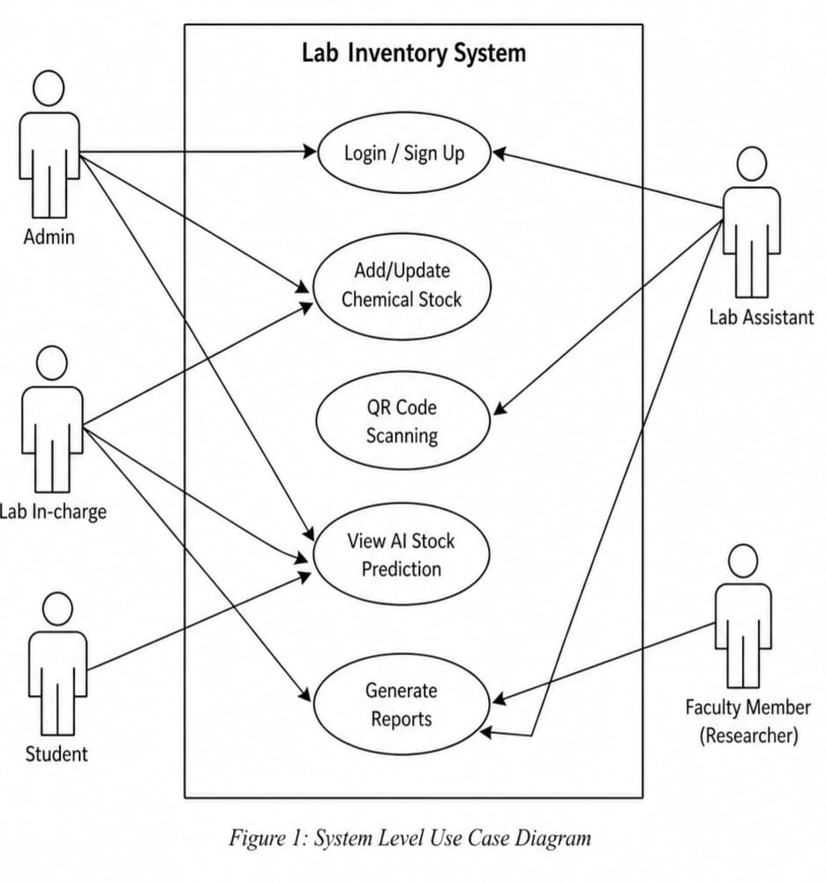

3.1 Use Case 1: User Registration (Sign Up)
ID | UC001
Name | Sign Up
Description | Allows new students or staff to create an account.
Actor(s) | Admin, Student, Faculty, Lab Assistant
Precondition | User must have a valid university email.
Basic Flow | Basic Flow  1. User enters Name, Email, and Role.  2. System validates the email format.  3. Account is created and sent for Admin approval

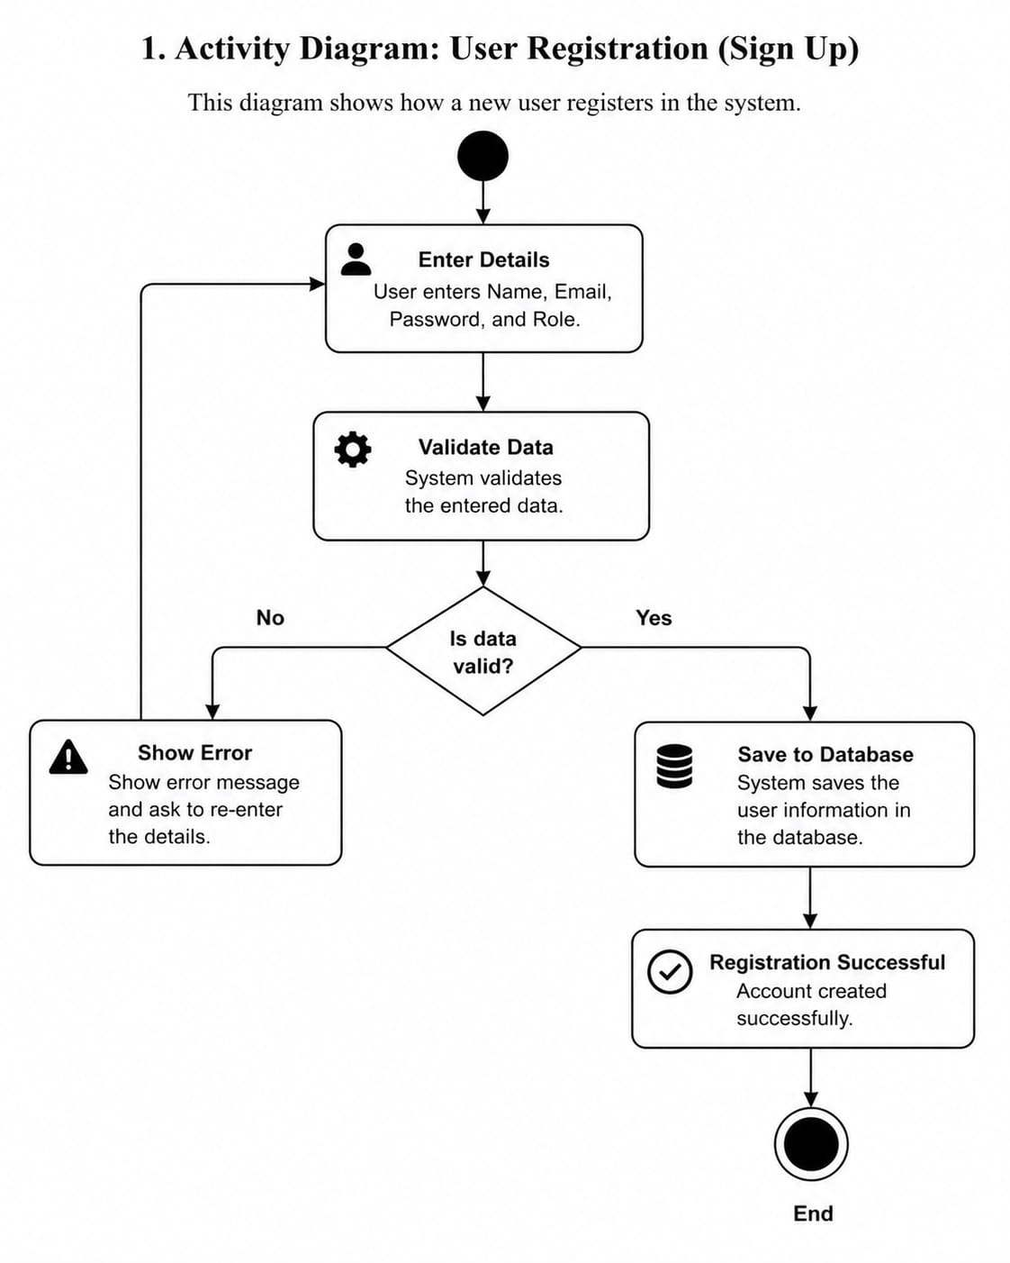

3.2 Use Case 2: User Login
ID | UC002
Name | User Login
Description | Authenticates users to access the inventory dashboard.
Actor(s) | All Actors
Precondition | User must have an approved account.
Basic Flow | Basic Flow  - User enters Email and Password.  - System checks the MySQL database.  - System redirects the user to their specific dashboard.

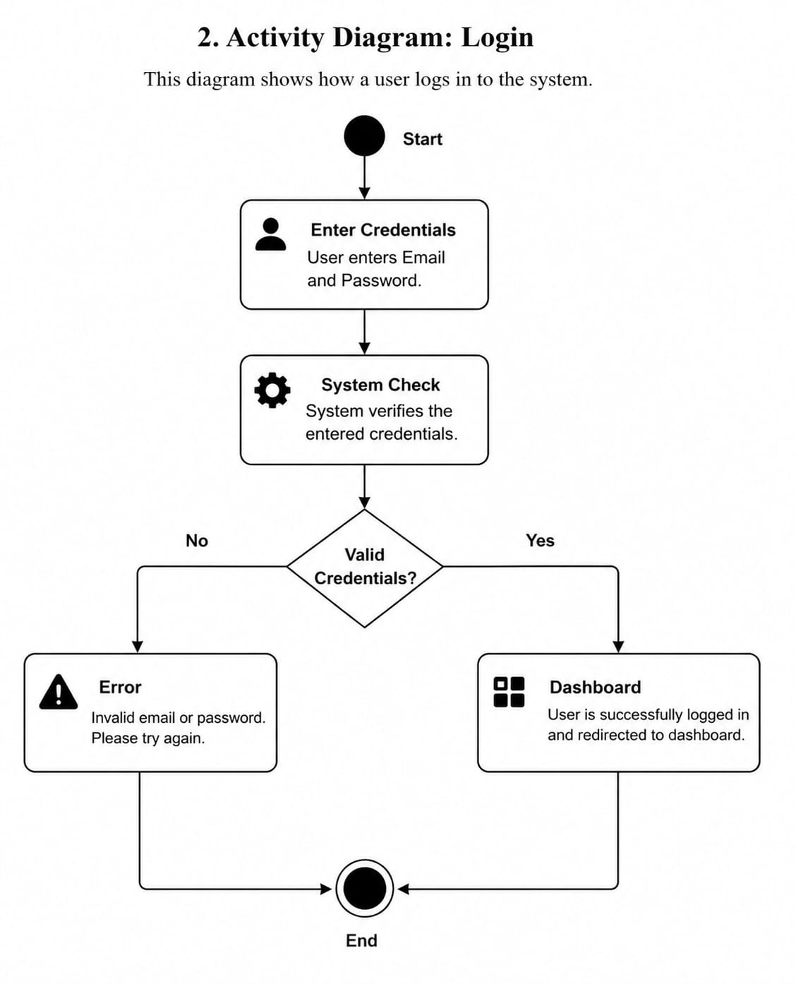

3.3 Use Case : Add/Update Chemical Stock
ID | UC003
Name | Manage Chemical Stock
Description | Allows Admin or In-charge to add new chemicals or update quantities.
Actor(s) | Admin, Lab In-charge
Precondition | User must be logged in with staff permissions.
Basic Flow | Basic Flow  1. Staff enters Chemical name, formula, and expiry.  2. System saves data and generates a unique ID.  3. Inventory levels are updated in real-time.

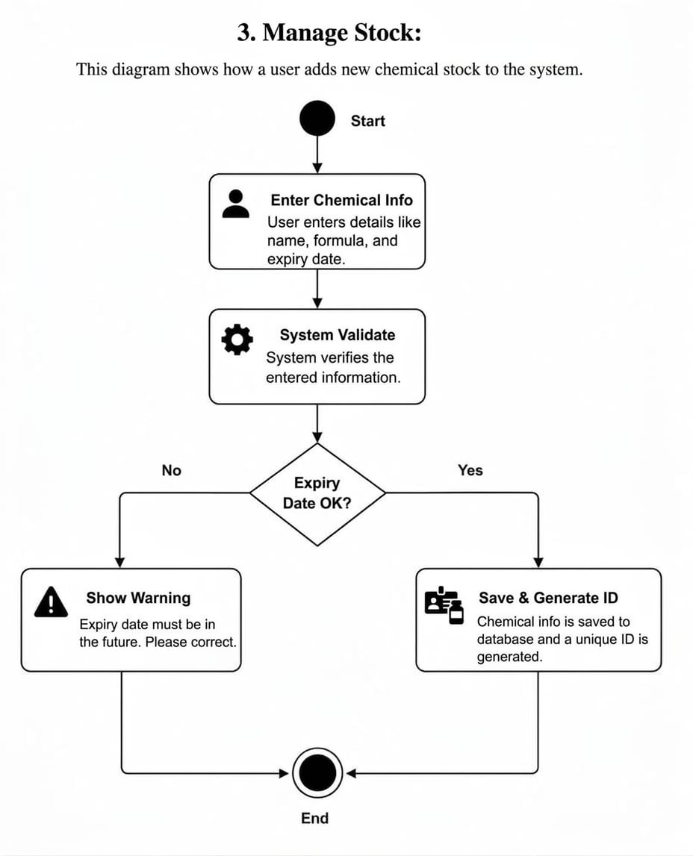

3.4 Use Case 4: QR Code Scanning
ID | UC004
Name | QR Code Scanning
Description | Users scan a bottle to quickly see its safety (MSDS) and status.
Actor(s) | Student, Lab Assistant, Faculty
Precondition | Mobile camera or scanner must be active.
Basic Flow | Basic Flow  1. User opens the scanner icon.  2. System reads the QR code.  3. System displays Chemical Name, Expiry, and Safety precautions.

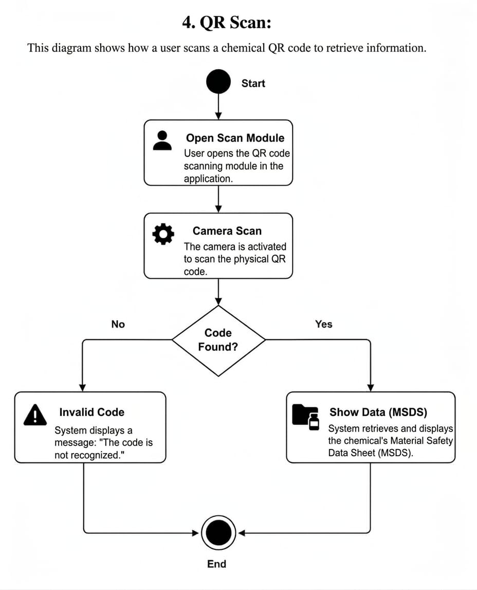

3.5 Use Case 5: Generate Reports
ID | UC005
Name | Generate Reports
Description | System creates PDF/Excel reports of usage and stock levels.
Actor(s) | Admin, Lab In-charge
Precondition | There must be enough data (logs) in the system.
Basic Flow | Basic Flow  1. Admin selects "Report Type" (e.g., Monthly Usage).  2. System fetches data from the database.  3. A downloadable PDF report is generated.

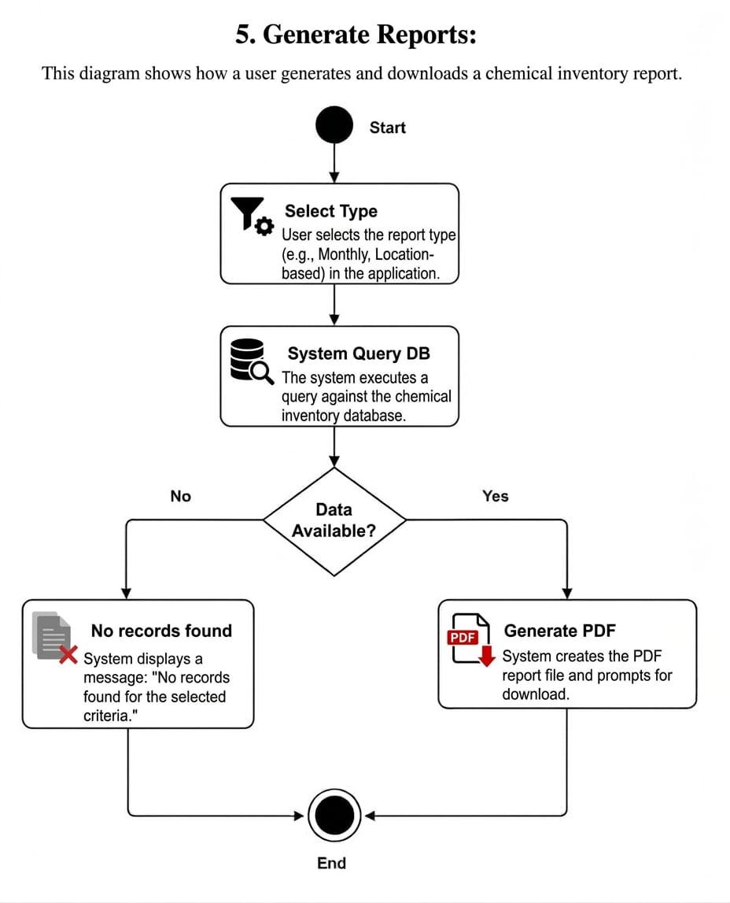
- References
- Django Software Foundation (2026) :
Django Documentation :The Web Framework for Perfectionists with Deadlines. Retrieved from https://docs.djangoproject.com/
- Python Software Foundation (2026) :
Python Language Reference, version 3.12. Retrieve from https://www.python.org/doc/
- MySQL (2025):
MySQL 8.0 Reference Manual. Oracle Corporation.
4. UML Activity Diagrams(2026):
Standard Graphical Notation for Software Workflows. International Journal of Software Engineering.
5. Smart Lab Inventory Management(2025):
Implementing AI and QR Codes in Chemical Laboratories. Journal of Information Technology and Research.

